Report on StarterBook

1. Given the provided data , what are three conclusions we can draw about Kickstarter campaigns?

The Kickstarter campaign which is massively successful for the crowdfunding service has definitely a positive outcome for various projects.

We can draw one conclusion that overall there is more than 2 billion raised, and the currency that has the highest funding is HKD.

We can check state wise, if the project has been successful and has pledged the goal amount as per Staff_picks and Spotlight. This conclusion gives us an insight that country US has higher goal amounts and the Staff_pick is False for the respective category.

We can draw another conclusion that overall, Category Theater has highest successful projects.

We can check the pivot charts for reference in the Excel Workbook

Name: [StarterBook](https://utoronto-my.sharepoint.com/personal/jasmeet_bassan_mail_utoronto_ca/Documents/StarterBook.xlsm?web=1)

1. What are some limitations of this dataset?

We can say there is one limitation to the dataset ie it has division by zero for the calculation of Average Donation and it has no mathematical formatting for the same.

Another limitation for the data set is that the demograph has to be researched better for the searching a way to success for the respective project. The dataset limits to the amount pledged and does not describe the opinion of the targeted audience.

The coulmns are not as specified in the questions. The workbook as taken as a connection and then queries were performed on it.

1. What are some other possible tables and/or graphs that we could create?

We can create a pivot table of the amount pledged per country as per respective currency for every name. The below is the screenshot of the table and graph. You can also check the Excel sheet for the same. The Sheet Name is Average Donation by currency.

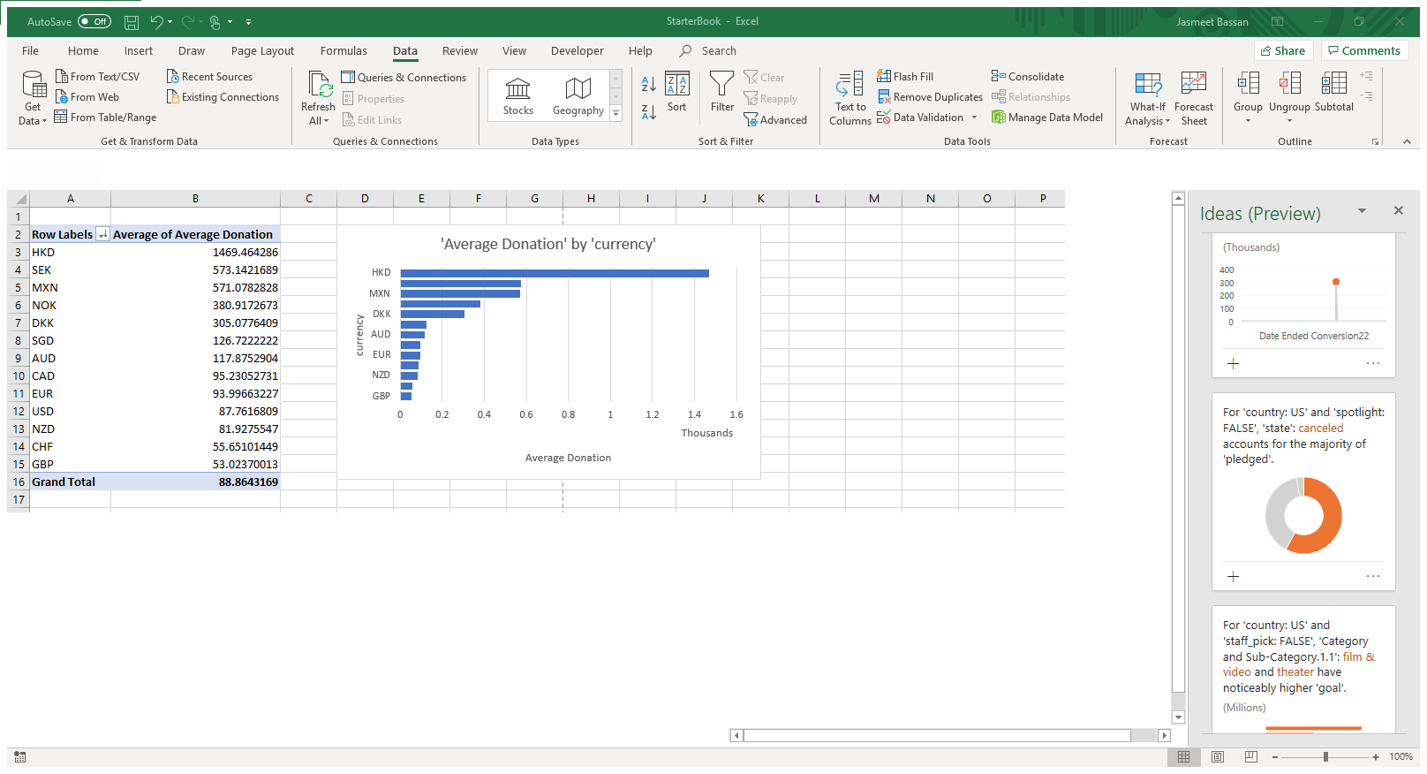

We can draw another pivot for Staff Pick False and Category Film & Video; the country that corresponds to this is US. This chart is updated in the Excel Workbook as well for clear reference.

We can check the pivot chart below:

